**Introduction to Respiratory System**

* **External respiration**: respiratory function, exchange of and
  + **Ventilation**: breathing, air exchange between lungs and external environment
  + Diffusion: alveoli ⬄ capillaries
  + Transportation: blood carries and
  + Diffusion: capillaries ⬄ tissues
* **Internal respiration**: metabolism produces heat and , consuming
* Non-respiratory functions:
  + water loss (humidification of alveoli) & heat elimination (from water loss)
  + **venous return** (respiratory pump)
  + vocalization, smell
  + defecation, childbirth
  + **blood reservoir** for left heart

**Respiratory System Anatomy**

* **Nasal passage > pharynx > larynx > trachea > bronchi > bronchiole > alveoli**
  + Convection, low SA, high speed (need energy) => diffusion, high SA, low speed
  + Skeletal + smooth => smooth => none
* **Lung**: 3 lobes right, 2 lobes left; cardiac notch (where heart sits) in lower left lobe
* **Thorax** (chest wall):
  + **Inspiratory** muscles: inhale
    - **Diaphragm**: innervated by phrenic nerves (C3-5), 50-70% of enlargement
    - **External** **intercostal** muscles: between ribs, stabilize the chest wall
  + **Expiratory** muscles: exhale
    - **Internal intercostal** muscles: between ribs, inside external intercostal
    - **Abdominal muscles**: only when active expiration
  + Support:
    - **Ribs**:12 pairs joining vertebrae posteriorly, 1–7 join sternum anteriorly
    - Diaphragm
* **Pleural sac**: two parietal membranes (endothelial cells) on thorax and lung, contains **pleural fluid** (lubrication, prevents friction), inflammation (**Pleurisy**) painful
* **Conducting zone**: trachea and large bronchi; filters, warms, and humidify air
  + **Smooth muscle** and rings of **cartilage**
  + **Epithelial** cell lining: mucus (trap ) and cilia (escalate trapped particles up)
  + **Bronchitis**: bronchial inflammation
    - Acute viral illness: cough to expectorate the mucous (i.e., flu, cold)
    - Diagram

      Description automatically generatedChronic obstructive pulmonary disease: airway injury via inhaled irritants
* **Terminal Bronchioles**: smooth muscle by ANS, no cilia / mucus (alveolar macrophages)
* Alveolar Exchange Zone: **Alveoli**
  + Type I (lining, very thin) vs Type II (membrane embedded) alveolar cells
  + *Collapsing pressure = 2surface tension/radius; prevent smaller alveoli collapse
    - **Pulmonary surfactant**: secreted by type II, reduces surface tension (reduce more for small radius)
    - **Alveolar interdependence**: structurally supported by neighbours
  + **Alveolar macrophages** guard lumen
  + Collateral ventilation (between alveoli) via **pores of Kohn** when airway blocked
  + **Infant Respiratory Distress Syndrome** (RDS)
    - Premature infants born without sufficient surfactant, can’t breathe
    - Surfactant replacement therapy given via an endotracheal tube
  + **Pneumonia**: alveoli inflammation, mucus affects diffusion & gas exchange

**Work of Breathing**

* Only ~3% of energy, lung is usually “half full”
* **Compliance**: amount of effort required to stretch/distend
  + Less compliant: harder to inflate (doesn’t comply)
* **Elasticity**: elastic properties due to elastic tissue and surface tension
* Flow (**volume**/time) = **pressure**/**resistance**,
* **Resistance**: mostly radius of airway
  + Text

    Description automatically generated**ANS** control Bronchoconstriction vs bronchodilation
  + Chronic obstructive pulmonary disease: ↑ airway resistance by ↓ radius
    - Chronic bronchitis
    - Asthma
* 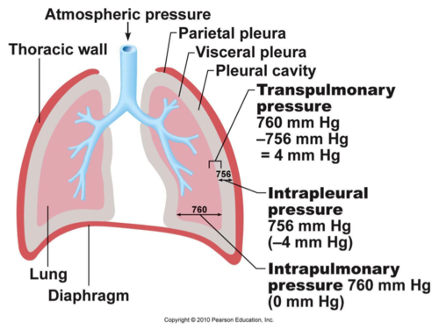**Pressures**: air flow due to pressure
  + **Atmospheric** / barometric pressure (760 mm Hg)
  + **Intrapulmonary** / alveoli pressure: forces air to flow in (< 760) or out (> 760) the lung
  + **Intrapleural** / intrathoracic pressure: pressure in pleural sac (between lung and chest wall), smaller than alveoli pressure, gradient keep lung inflated
    - **Lymphatic system** (one way, route for fluid (lymph) return to blood, defence (phagocytes)) drains intrapleural fluid, generating negative intrapleural pressure
    - **Pneumothorax**: rupture in pleural sac, no pressure gradient, lung collapse
  + **Transpulmonary** pressure / lung recoil pressure: intrapulmonary – intrapleural, always positive, lungs & chest wall never in natural positions at the same time
* 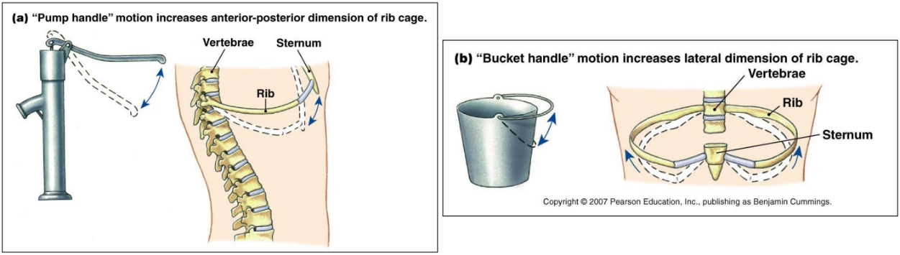**Inhalation & Exhalation**: muscle contraction / relaxation / recoil => change thoracic cavity size => change intrapleural pressure => change intrapulmonary pressure
  + Volume change: 60-75% diaphragm, 25-40% rib cage movement
    - Boyle’s law: , volume change => pressure change
  + Hering-Breuer reflex inhibits overinflation
  + **Equal pressure point**: airway compressed (blocked) during exhale

**Ventilation**

* **Diagram

  Description automatically generatedDiagram

  Description automatically generatedSpirometer** measures lung volumes, generates **spirogram** (average shown below)
  + Forced expiratory volume in one second (): volume of air expired during first second of maximal expiratory effort starting from TLC
    - Usually expressed as ratio of /VC (what % can be expired in 1 s)
    - Chart

      Description automatically generatedDiagram

      Description automatically generatedCan be used to distinguish obstructive vs restrictive diseases
  + Expiration is more important because it is limiting
* **Pulmonary ventilation** (, expiratory): * respiratory rate
  + As ventilatory demand increases, increases first, then increases
* **Alveolar dead space** (): ~ 150 mL, useless air
  + Quite small and unimportant for healthy people
* **Alveolar ventilation** (): (respiratory rate)

**Gas Exchange**

* Diffusion at alveolar–capillary membrane, depends on partial pressure gradient and resistance to diffusion (surface area SA & thickness T)
  + **Partial pressure gradient**: Dalton’s law – partial pressure percentage in air
  + Fick’s law of diffusion: rate depends on SA and T, ~ constant when healthy & rest
  + Text, letter

    Description automatically generatedA screenshot of a computer

    Description automatically generated with low confidenceBlood also has partial pressure depending on percentage dissolved

**100 40**

**40 46**

* + - 20 times more soluble than , accounts for much lower gradient
* Capillary transit time: when blood is in pulmonary capillaries (exposed to alveoli)
* **Ventilation** (gas exchange, facet) and **perfusion** (blood supply, drain)
  + Ventilated not perfused => alveolar dead space
  + Perfused not ventilated => shunts, anatomic dead space
  + **Vasodilation when high** ,vise versa, direct blood to better supplied alveoli
  + **Bronchodilation when high** , vise versa, more efficient gas exchange
  + **Systemic** **capillaries**: **vasodilation when low** , bring oxygen to tissue

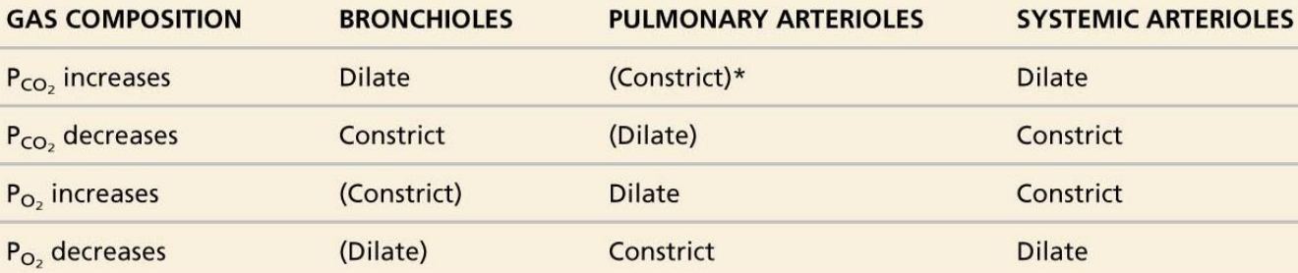

* **Lung capillaries**: collapsible at high pressure
  + At rest, capillaries at top (apex) of the lungs collapse (low hydrostatic pressure), capillaries at the base of the lungs are open (high hydrostatic pressure, gravity)
    - Blood flow is diverted toward the base of the lungs
  + During exercise, BP rises and the closed apical capillary beds open
    - Contributes to the “reserve capacity”

**Control of Breathing**

* Rhythmic pattern established by **respiratory control centers** (specifically the medulla)
  + Pneumotaxic centre: associated with prolonged expirations
  + Apneustic centre: associated with prolonged and deep inspirations
  + Pre-Bötzinger complex: contains pacemaker-like neurons
  + **Dorsal respiratory group** (DRG) contains primarily inspiratory neurons
    - Contract diaphragm for inhale, relax for exhale
  + **Ventral respiratory group** (VRG) contains both, for exercise
    - Open upper airway for in, contract to squeeze air out for ex
* Regulation of the level of ventilation (rate & depth of breathing) by receptors
  + **Peripheral chemoreceptors**: respond to oxygen
    - **Carotid bodies**: ventilation when
    - **Aortic bodies**: cardiac output when oxygen content
  + **Central chemoreceptors**: respond to
    - Very sensitive to partial pressure
    - 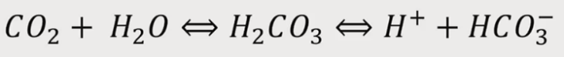Respond to pH ( induce changes, slower)
    - Graphical user interface, text

      Description automatically generatedRegulates resting ventilation ( is most important factor)
* Modificati­on of respiratory activity to serve **other purposes**
  + **Voluntary** via motor neurons
  + **Protective** (cough or sneeze)
  + Pain & emotion
  + Inhibited during swallowing
* Apnea: transient interruption of ventilation, breathing resuming spontaneously
  + Respiratory arrest: if breathing does not resume
* Dyspnea: breathlessness

